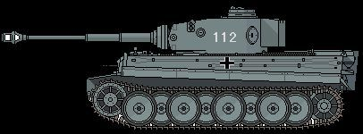
Figure 1Panzer leher
1st SS Pz
+1

